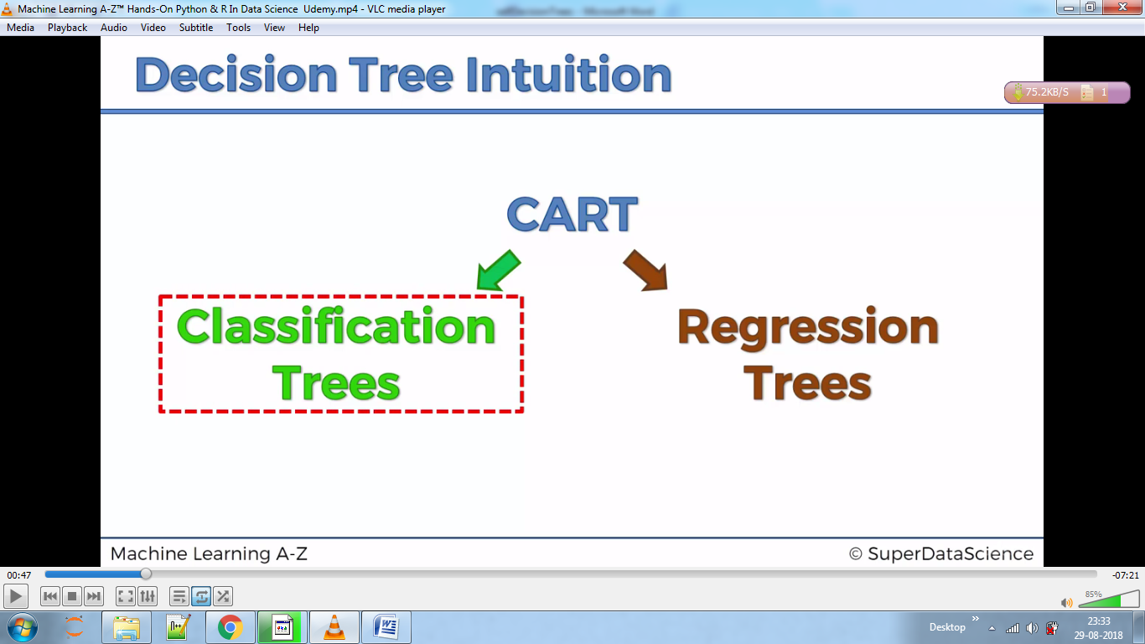

We split data

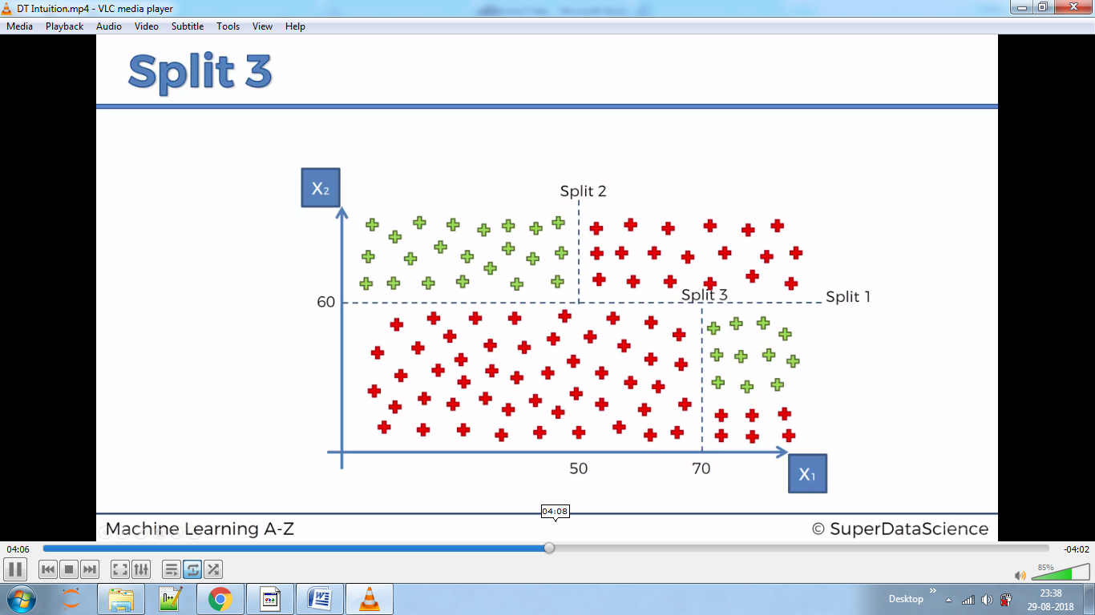

And conclude like below

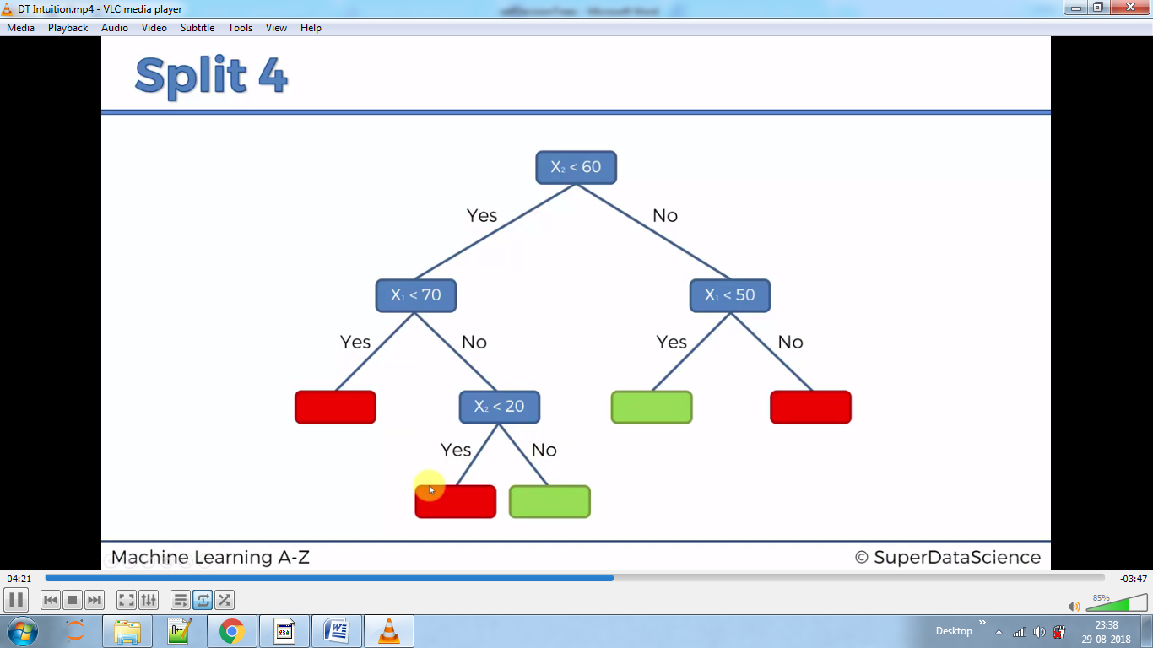

Decision trees are not on basis of Euclidean distance; therefore we do not need to apply Feature Scaling to the dataset.

Using criterion as entropy we bring homogeneity in the model

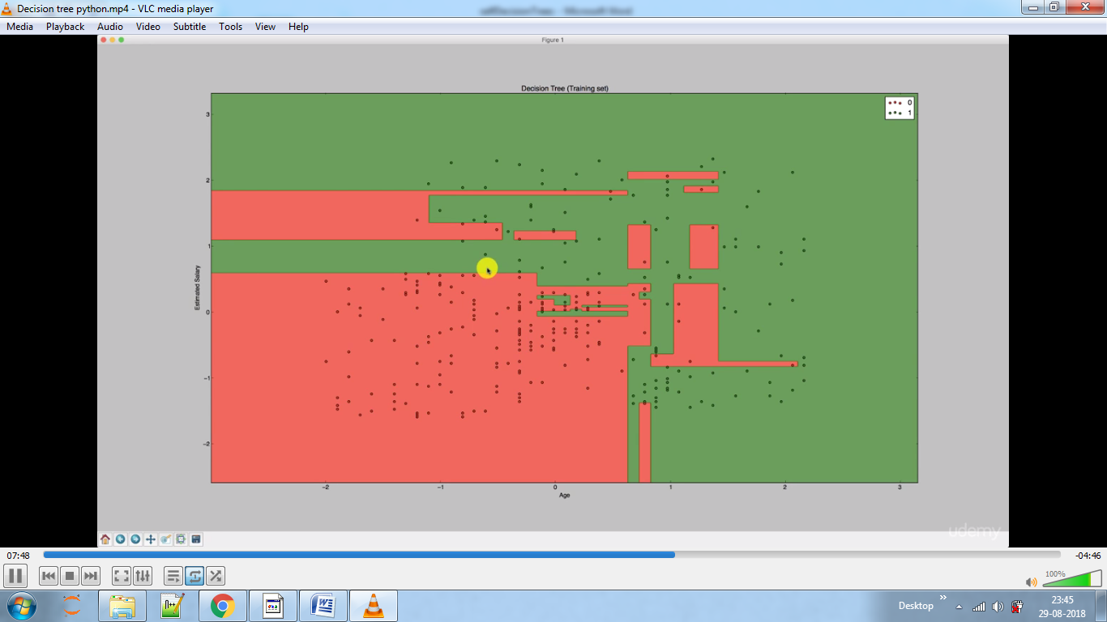

It kind of look over fitting.

Check this by comparing this with test set